Module 1 – the big problem

Mental wellbeing is still not given the emphasis and investment it needs in many workplaces. The Business in The Community Mental Health at Work reports regularly call for more to be done to train managers in supporting the mental health of their staff.
You can read their most recent report at:
https://www.bitc.org.uk/wp-content/uploads/2019/10/bitc-wellbeing-report-mhawmentalhealthworkfullreport2019-sept2019-2.pdf
The result is that poor mental health in the workplace cost the UK economy £34.9 bn in 2019.
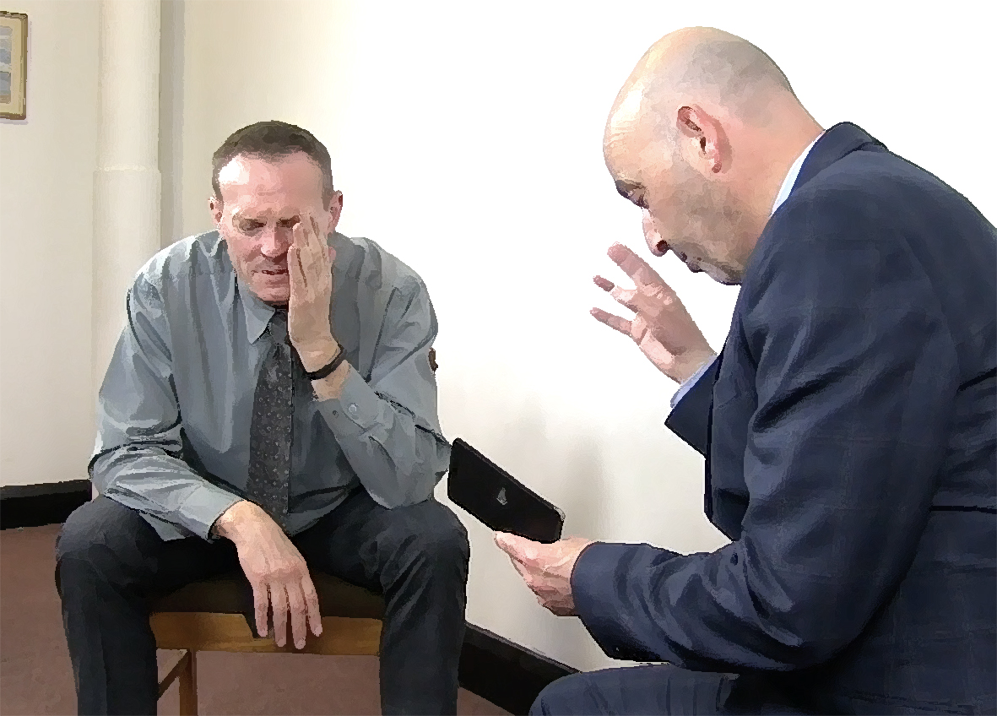
Like Rob in the scenario, this often comes down to managers not having the confidence and skills to have open conversations with their staff about mental wellbeing. Against their best intentions, it is easy for managers and colleagues to stop listening and go into ‘what can I do to help?’ mode.

This programme will give you the skills and confidence to create a workplace that supports mental wellbeing, rather than brushing it under the carpet. In the modules that follow, we will consider the essential skills you need:
Spotting the Signs Opening Up the Conversation
Lowering the Barriers Signposting Support
And first, we’ll take a step back and look at what we mean by ‘Mental Health’.

What is going through Jim’s head as he walks towards the door? What is going on in his body?

What thoughts are going through Jim’s head as he walks away from the meeting? What is he feeling?

What 3 things would you change about what Rob did:

Module 1 - REFLECTION TASK

Module 2 – what do we mean by ‘mental health’?


high wellbeing
It is important to understand mental wellbeing as a scale on which we all exist. We can move up and down this scale through our lives as our anxiety levels or degree of happiness fluctuate. Worries about money, relationships, health and so can pull us down the scale and positive events, achievements and relationships can push us up. Sometimes there might be no obvious reason for these fluctuations. They can move up and down over years, months or even within one day. This is perfectly normal human experience.

low wellbeing

The problems begin if someone gets ‘stuck’ in the lower part of this scale and cannot raise themselves out of low wellbeing. If this continues for long enough, they may be diagnosed with a mental health condition.
high
mental
illness

no
mental
illness

psychotic
mental health
conditions


2
common
mental health
conditions

Common (neurotic) mental health conditions
The most common mental health conditions, which are exaggerated versions of everyday human experience:
- Anxiety disorders:
generalised anxiety disorder (GAD)
post traumatic stress disorder (PTSD)
obsessive compulsive disorder (OCD)
phobias

- Depressive disorders:
major depressive disorder
pre- and post-natal depression
seasonal affective disorder (SAD)

Psychotic mental health conditions
Much less common conditions that often depart from ordinary human experience, with symptoms such as hallucinations and delusional thoughts:
schizophrenia bi-polar disorder psychosis
For more information, see the Mind website:
https://www.mind.org.uk/information-support/types-of-mental-health-problems/

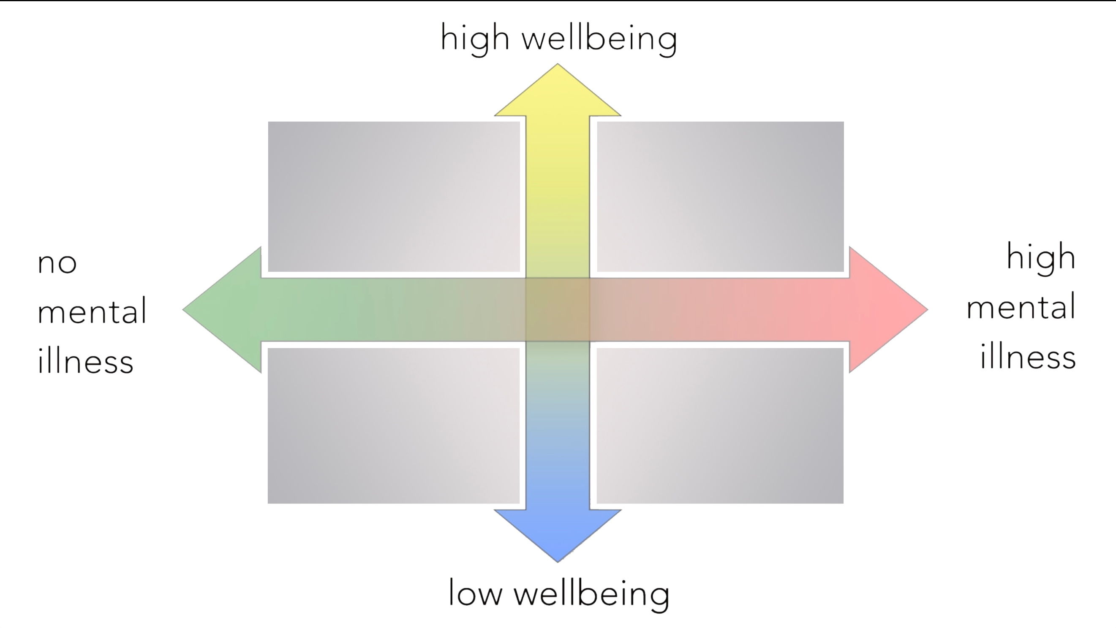
We can also consider these two scales as the quadrants they produce:
1
3
low mood but no diagnosed mental health problems

diagnosed condition and low mood

buoyant mood and no mental health problems

diagnosed condition, stable mood because of treatment & support

4
Like Jim, anybody can move around these quadrants through their lives.
It is worth considering quadrants 4 and 2 a little further:
Quadrant 4 – people can recover from mental health conditions – giving the lie to the stigma and stereotypes around mental illness.
Quadrant 2 – just because someone thinks they might be depressed (and has perhaps Googled) does not mean they have a mental health condition. GPs and medical professionals have clear criteria for making a diagnosis (see later).
Common triggers for mental health problems:

Home related
- bereavement
- financial worries
- relationship problems
- family illness
- discrimination

Work related
- excessive demands
- lack of control
- lack of support
- change (with poor communication)
- ill-defined roles
- poor relationships

It is important to be aware of such triggers for colleagues (and for yourself) so that you can be more alert to the signs that mental wellbeing is being affected.
Making a diagnosis

A GP or medical professional will be looking for the symptoms of mental health conditions. Here, we will deal only with the common mental health conditions. If you are working with someone with a diagnosed psychotic condition, such as bi-polar disorder or schizophrenia, you need to ask them and professionals to advise you on the best way of supporting them.
Common Symptoms of Depression
- Low mood that persists
- Loss of interest / pleasure in activities
- Lack of energy / tiredness
- Feeling worthless / guilty
- Thinking about death a lot
- Difficulty concentrating / making decisions
- Moving slowly / sometimes agitated
- Lack of sleep / sleeping too much
- Lack of appetite / eating too much

A GP will investigate these symptoms through discussion and sometimes, with the aid of a self-assessment questionnaire, such as The Beck’s Depression Inventory.
You can try out a simplified version of this, used by the NHS, or recommend it to colleagues:

In making their diagnosis, the GP will be determining:
NHS Mood Self Assessment
https://www.nhs.uk/conditions/stress-anxiety-depression/mood-self-assessment/
- Number of symptoms – at least 5 of the above are present, including the first 2
- Severity of symptoms – day-to-day functioning is being affected
- Persistence of symptoms – present for at least 2 weeks
Common Symptoms of Anxiety
- Fast heart rate and fast breathing
- Feeling tense
- Perspiring excessively
- Sleep disturbance
- Changes in eating habits
- Thinking something bad is going to happen
- Feelings of fear and shame
- Avoiding stressful situations

Treatments

Depending on the degree of depression or anxiety disorder, the medical professional will prescribe from a range of treatments:
- Medication – different medications affect people in different ways and it may take a while to get the right drug and dose

- Talking Treatments – such as Cognitive Behavioural Therapy, Psychotherapy, Counselling, etc.
- Social Prescribing – prescriptions for exercise, learning, cultural and social events
- Self Care – following the recommendations of the 5 Ways to Wellbeing approach
You can find out more about treatments by using the In Detail links on the website and by visiting Mind:
Mind on treatments
https://www.mind.org.uk/information-support/drugs-and-treatments/

Module 2 – what do we mean by ‘mental health’? - REFLECTION TASK

If you were his manager, what could you do to support Jim’s recovery?

What could you do more of to support the mental wellbeing of your staff?

Module 2 – stress and mental health

Stress is not a mental health disorder; it is a perfectly normal and necessary response to challenge and difficulty (threat). However, if it isn’t managed and moderated, it creates fertile ground for mental health problems to develop.
We get stressed when our automatic threat mechanisms are triggered, releasing adrenalin and cortisol, the stress hormone. This sets off a range of responses in our body:
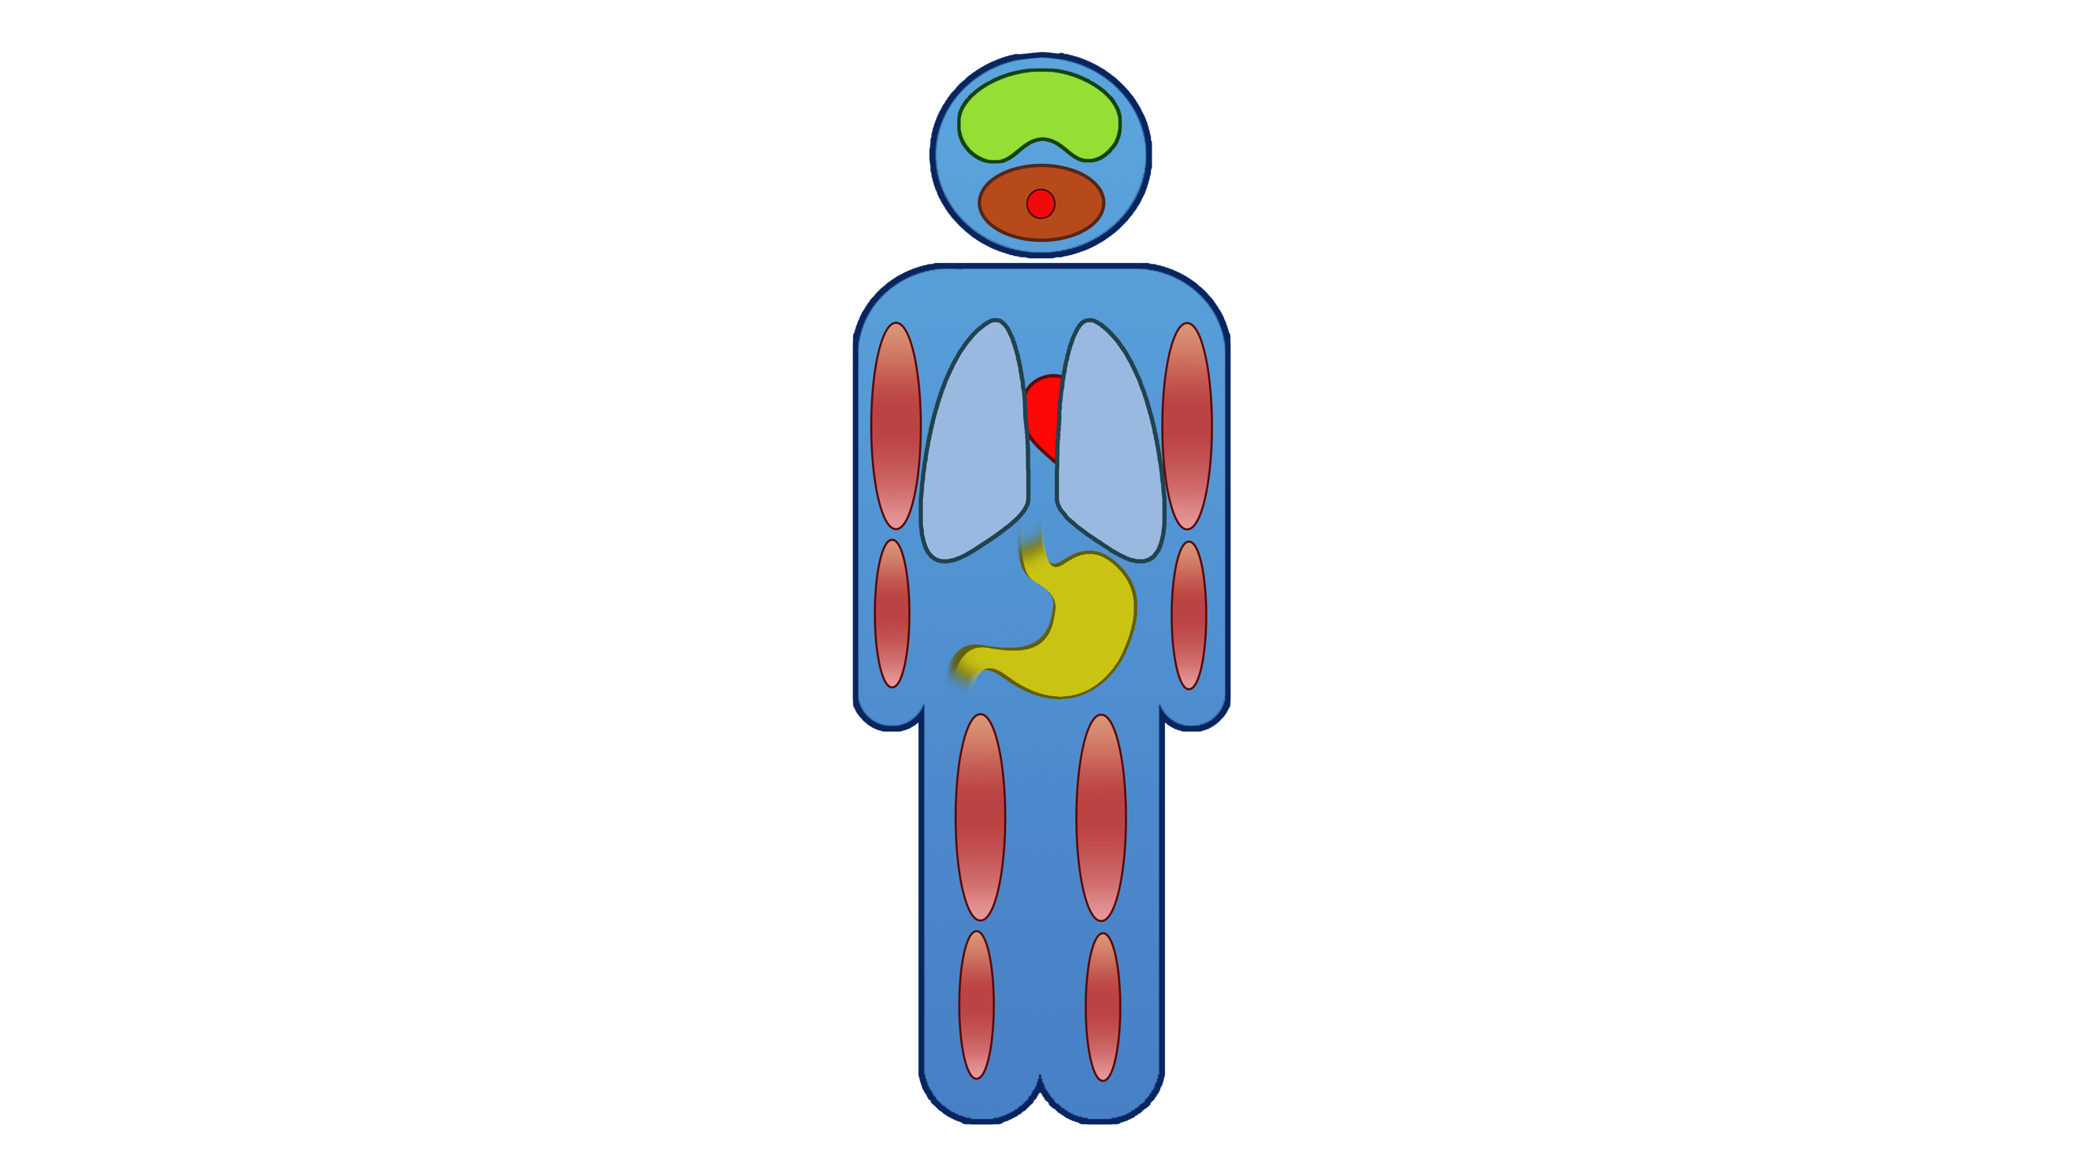
the ‘thinking brain’ is shut down
the amygdala triggers adrenalin
and cortisol production

muscles tense, ready for
action

heart rate and breathing
increase

blood pressure increases

digestion is shut down

blood thickens, in case of injury

This response can be caused by different types of triggers:
Internal Threats
- worries
- negative thoughts
- speculation
- doubts
External Threats
- conflict
- lack of food, sleep, etc.
- debt
- work pressures
If the threat response remains switched on because of internal, threatening thoughts, over time, this can lead to serious health conditions, such as heart disease, IBS and skeletal / joint problems.

Module 2 – stress and mental health - REFLECTION TASK

What can you do to reduce at least 1 external threat?

Think about the 5 Ways to Wellbeing – what can you do differently?

Module 3 – spotting the signs

You need to be observant when it comes to your team, ensuring that no one falls off your radar. Team members often don’t have the confidence to speak up, so you need to be able to spot the outward signs that someone may be experiencing mental health problems.
Spotting change is crucial in recognising signs, so that you are not drawn into stereotypes of how someone experiencing mental health problems will behave.
Typical Signs can be broken down into 5 areas:
Remember that you need to stay alert to CHANGES in colleagues and this means you need to have a ‘baseline’ for their normal behaviour.
- Conduct – how someone behaves and interacts with others. Often, they will withdraw and become quieter BUT they might become more outgoing as a ‘front’ or as the result of the condition or medication
- Appearance – often, they will lose interest in self-care and their appearance will deteriorate BUT they might take even more time on appearance as a ‘front’, in the hope that no one will notice.
- Performance – will usually deteriorate because of impaired brain function BUT it may improve (for a time), as an attempt to ‘hang on’.
- Work Patterns – they may start being late or taking sick days, BUT, they might start being in work more as they, for example, keep away from home or try to find a hiding place.
- Physical Health – you may notice changes in weight (up or down), signs of sleeplessness, or increased general illness such as colds as a result of an impaired immune system.
And remember to strike a balance in your sign spotting:

ignore it
altogether
check it out
jump to
conclusions

Module 3 – spotting the signs - REFLECTION TASK

What signs did you spot that Jim’s mental health is not good?

What can you do to improve your sign spotting?

Module 3 – building and maintaining resilience

Remember the poor deformed tree, clinging on for dear life under the pressure of an unrelenting gale.


This is NOT how we build resilience. Nassim Nicholas Taleb has a much better, healthier approach:
Resilience is the result of how you RECHARGE
not how you endure
This needs to be considered from a personal and organisational angle.
Personal Resilience
Do you allow yourself to recharge? There is a range of opportunities to do so:

micro break lunch / tea break home time holiday
RECHARGE
- micro breaks – a few minutes to have chat, read, take a deep breath, etc.
- lunch / tea breaks – taking a proper lunch, away from your computer
- home time – actually leaving work behind and spending time at home
- holiday – great, but infrequent, so don’t rely on them!

Develop some rituals to mark the beginning and end of your day

My entrance ritual:

My exit ritual:

Module 3 – building and maintaining resilience - REFLECTION TASK

A valuable way of recharging is to remind yourself of the purpose and meaning of your work, for you – why do you keep doing it! Do a simple drawing or write a few words to capture the essence of your meaning, then build this into your entrance ritual – put up the poster, put it on your screensaver, etc. to start the day with a reminder of your overarching purpose.
The meaning of my work

:

Organisational Resilience

The Health and Safety Executive’s 6 Management Standards lay out the conditions that organisations need to consider in ensuring that their staff remain healthy – mentally and physically – and are able to build and maintain their resilience.
The 6 Management Standards
The Management Standards cover six key areas of work design that, if
not properly managed, are associated with poor health and wellbeing, lower productivity and increased sickness absence. In other words, the Standards cover the primary sources of stress at work.
- Demands
Includes issues such as workload, work patterns and the work environment.
- Control
How much say do the people have over the way they work?
- Support
Includes encouragement, sponsorship and resources provided
by the organisation, line management and colleagues.
- Relationships
Includes promoting positive working to avoid conflict and dealing
with unacceptable behaviour.
- Role
Do people understand their role within the organisation and does
the organisation ensure roles are not conflicting?
- Change
How is organisational change (large and small) managed and communicated?

What positive changes can you make in these 6 areas?

Module 3 – building and maintaining resilience - REFLECTION TASK

Maintaining positive relationships is essential in building resilience. The research shows that the ratio of positive to negative interactions needs to be at least 5 : 1 to nurture a healthy team.
Module 3 – building and maintaining resilience - REFLECTION TASK

What can you do to create a more positive working environment?

Module 4 – lowering the barriers

Just at the point when you may have spotted the signs that someone isn’t coping, you can anticipate that certain barriers will kick in – barriers that will try to stop you doing anything.
Common barriers
- ‘I haven’t got time for this!’ – remind yourself that spending a little
time now could save a lot of time later if the person goes off sick.
- Lack of confidence – managers and colleagues often worry that they will make things worse because they don’t know what they’re doing. Remember – the worst thing you can do is ignore it. Use this course to build your confidence by improving your knowledge and practicing your skills.
- Stigma – the centuries old prejudices about mental illness still affect people’s attitudes and behaviours. Even though stigma is gradually reducing, it can still prevent people from offering or asking for help. Make sure that you are working from knowledge rather than old prejudices and stereotypes by ‘filling in the gaps’ in your understanding and the understanding of your colleagues.
- Bystander effect – the tendency for people to believe that ‘someone else will do it’ and go along with the crowd in ignoring the issue. Remember – you need to be the builder, the one who stops and send out the message ‘we will support you’.



are you the builder,
or the newspaper
reader?

What can you do to ‘fill in the gaps’ in your workplace?

What can you do to send out the message ‘I will support you’?

Module 4 – lowering the barriers - REFLECTION TASK

Module 4 – 5 ways to wellbeing

Evidence suggests there are 5 steps we can all take to improve our mental wellbeing. If you give them a try, you may feel happier, more positive and able to get the most from life.


Take Notice – be more aware of the present moment, including your thoughts and feelings, your body and the world around. Some people call this "mindfulness". It can positively change the way you feel about life and how you approach challenges.
Connect – connect with the people around you: your family, friends, colleagues and neighbours. Spend time developing these relationships.

Be active – you don't have to go to the gym. Take a walk, go cycling or play a game of football. Find an activity that you enjoy and make it a part of your life.


Keep learning – learning new skills can give you a sense of achievement and a new confidence. So why not sign up for that cooking course, start learning to play a musical instrument, or figure out how to fix your bike?
Give – even the smallest act can count, whether it's a smile, a thank you or a kind word. Larger acts, such as volunteering at your local community centre, can improve your mental wellbeing and help you build new social networks.
NHS on the 5 ways to wellbeing
https://www.Nhs.Uk/Conditions/Stress-Anxiety Depression/Improve-Mental-Wellbeing/

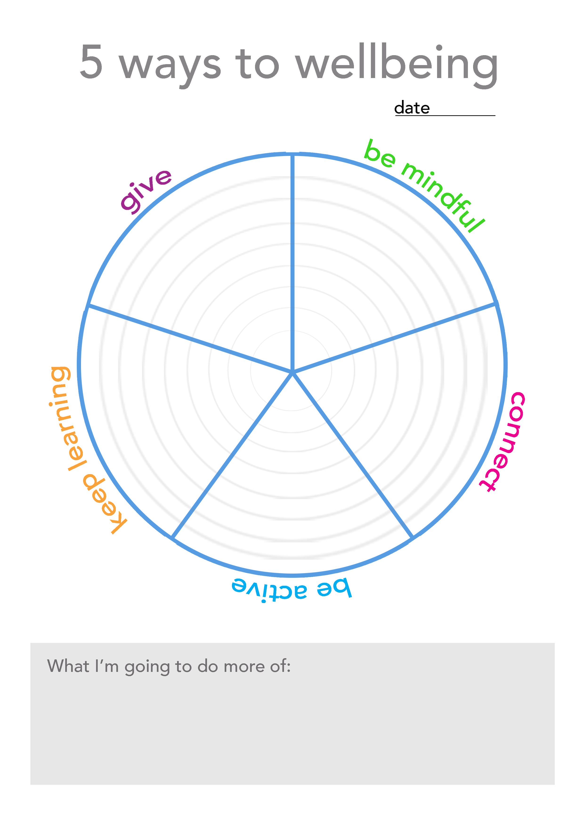

Module 5 – opening up the conversation

You’ve spotted the signs, you’ve lowered the barriers, now it’s time to actually have the conversation about your concerns. This is often the scariest part and a bit of preparation will really help.
Preparing for the conversation
- Gather information – attendance records, etc, personal observations,
details of the support that is available
- Where – consider the best place to talk, from the most formal – a private room, to the most informal – going for a walk and anywhere in between. If it’s possible, ask for their preference as it will help empower them from the beginning.
- When – make sure that both of you have a decent amount of time to spare and don’t do it last thing on a Friday, for example.
- Your aim - it is important to be clear about your aim for the discussion. Don’t think that you are going to ‘get it all sorted out’. You should be pleased just to make a start on opening-up the issue – if you push too hard, they are likely to shut down. Plan for different possibilities but …. don’t script the conversation – it rarely turns out just as you imagined it would.

The conversation
- Just get them talking
Allow them to feel at ease and gain
confidence in talking about a
relatively ‘safe’ subject and then
listen for clues to what may be
going on ‘behind the mask’.

- Actively Listen
Without doubt, the most useful skill you can use in helping a person with a mental health issue is active listening. Try to really listen to the person and avoid formulating your response before they have finished speaking. Aim for a discussion rather than an interview. Remember that you may need to allow ‘space’ for the person to express themselves.
- To express your concern
It’s all very well getting them talking, but what if they are talking about what they did at the weekend and you really want to bring it round to the point? You need to describe behaviours, and don’t offer a diagnosis: “I’ve noticed that you ….” rather than “I’m worried you might be a bit depressed”!
- Don’t jump to solutions
It is very easy to slip into ‘manager’ mode and start trying to find solutions. You will need to come to how to offer practical support but if you do it straight away, you may not have the conversation you really need. We will look at the support you can offer in the next module.
- Allow silence
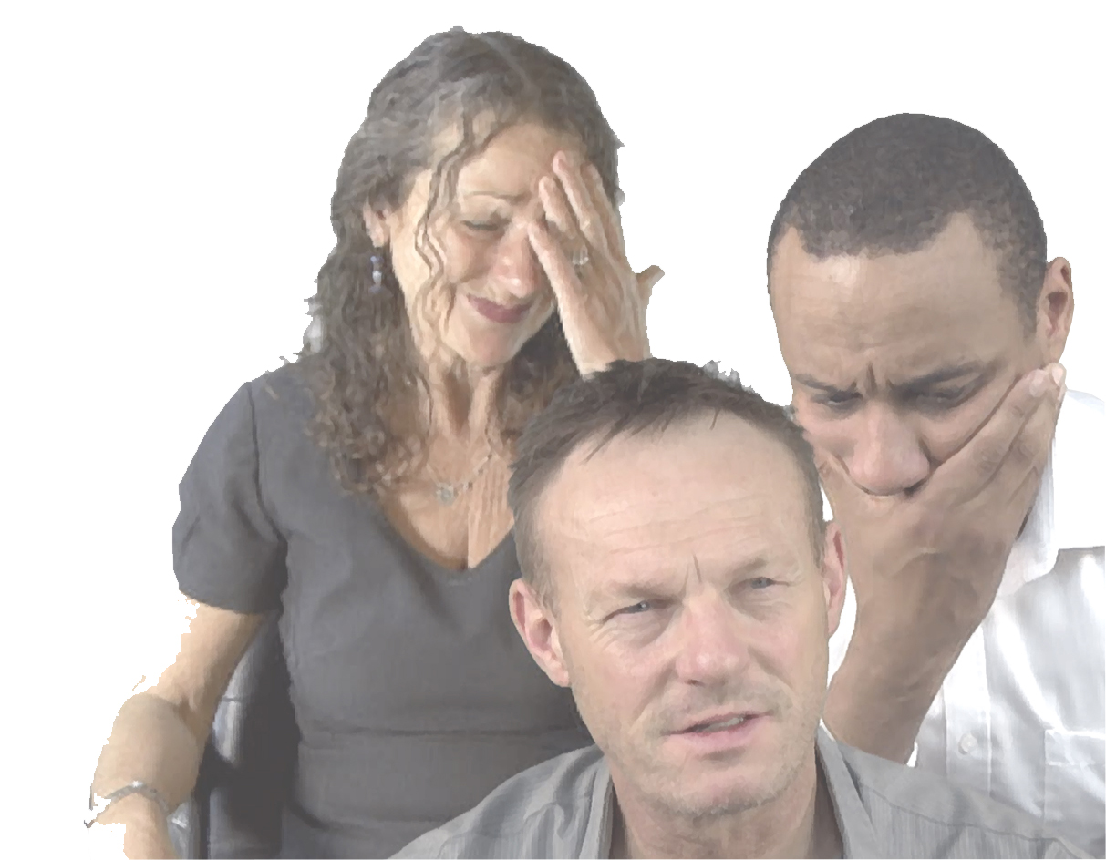
Don’t let your own anxiety disrupt their process – allow them time to reflect. If they are really stuck, you can try ‘Naming what you see’: “I can see that you are worried about this”, “I can tell that you’re anxious”.
- What if they cry?
Be aware of your own instinctive response to tears – are you a runner or a hugger? – and make sure that your response is helpful.
- What if they ask for confidentiality?
You need to gently explain that you will not talk to anybody about this unless they want you to but if you are concerned about their wellbeing then you will have no choice but to share your concerns.
Remember:
A conversation like this will have an emotional impact on you, so allow yourself a little time to ‘de-compress’ afterwards.

How can you get Lucy talking?

What would you do if Lucy cried?

Module 5 – opening up the conversation - REFLECTION TASK

What would you say if she asked for confidentiality?

What are you 3 most important learning points?

Module 5 – opening up the conversation - REFLECTION TASK

Module 6 – signposting support

Your responsibilities
Remind yourself of your role in supporting someone’s mental wellbeing.
Your job is to signpost them to proper professional support. You will continue to talk to them, encouraging them to take up the support you’ve signposted but you are not going to become their personal counsellor or emotional crutch. That wouldn’t be healthy for you – or for them.
You need to be confident to:
- Keep everyone on your radar and spot the signs if someone is struggling with their mental health
- Make sure that you don’t let those barriers prevent you from acting
- Open up the conversation
- Signpost them to the professional help they need and continue to encourage them to take up that support
First, you should signpost them to the support available
Within your organisation
- Do you have an Employee Assistance Programme (EAP) or Health benefits scheme? If they’d like counselling then they may get it much more quickly via this route, rather than through the NHS.
- Is there an HR specialist or OH team they can talk to?
… and remember
all this support – in work and beyond is also there for you – for advice on how to support someone, your options as a manager or colleague and, of course in keeping yourself healthy.
- You can also point them to the reasonable adjustments that could be made by your organisation, such as changes to work patterns or temporary adjustments to workload. If you’re a manager, you may be able to organise some of these immediately but if you’re in any doubt do talk to HR about it.

Beyond your organization
- You should always ask someone if they’ve seen their GP and if they haven’t, encourage them to do so. They need a proper medical opinion, diagnosis and advice on treatment.
- There are many very good Charities and independent organisations offering telephone and online support, through to face to face counselling. As well as the general mental health charities, such as Mind, there are organisations dealing with specific issues such as bereavement, PTSD, eating disorders, post-natal depression, etc. There are also organisations that work in specific regions.

For a full directory of such organisations, have a look at:
Directory of Mental Health Charities
https://www.charitychoice.co.uk/charities/mental-health

Follow it up
Once you’ve done the signposting, you have to follow it up. You could email the person immediately to remind them of what you’ve suggested. Having it written down can help make it more concrete and reinforce the message that you will support them.
Arrange a time to check in with them and ask how they’ve got on. Be gentle but firm. Sometimes, particularly if someone is feeling hopeless and helpless, they need a bit of outside pressure to act – someone else that they’re doing it for, someone they don’t want to let down.

:

Support available in my organisation

:

My Mental Wealth Action Plan



Centre for Mental Health
Developed by NEF (the New Economics Foundation) as part of the government’s Foresight Project on Mental Capital and Wellbeing.

